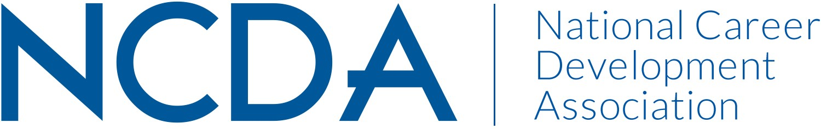

NCDA RESEARCH COMMITTEE REPORT

SEPTEMBER 15, 2025

Chair:
Deb Osborn
1114 W. Call Street
The Florida State University
Tallahassee, FL 32306-4053
dosborn@fsu.edu

Co-Chair:
Jon Borland
East Tennessee State University
PO Box 70701
Johnson City, TN 37614-1710
borland@etsu.edu

Co-Chair:
Brian Calhoun
Associate Professor of the Practice, Department of Education
Tribble Hall - Room A308B
Wake Forest University
P.O. Box 7406
Winston-Salem, NC 27109
calhoubm@wfu.edu

List Committee Members

Jonathan Adams
Sungsik Ahn
Shadin Atiyeh
Elif Balin
Abby Bjornsen-Ramig
Jon Richard Borland
William Briddick
Nathaniel Brown
Emily Bullock
Stephanie Burrows
Brian Calhoun
Darrin L Carr
Chris S DaSambiagio-Moore
Abiola Dipeolu
Melanie Evangelista
Lia D – Falco
Seth C. W. Hayden
Latoya Haynes-Thoby
Janet Hicks
Youn Jung Ho
Kimberly Howard
Chris Lafever
Jason Li
Qiong Li
Yangyang Liu
Ayla Ludwig
Julia Makela
Spencer Niles
Kelechi Nnaji
Sarah Patterson-Mills
Sabrina Quiroga
Patrick J. Rottinghaus
Donna E Schultheiss
Rana Sedeeq
Patricia Smith
V. Scott Solberg
Jacob Stamm
Tennille Sullivan
Mitali Temurnikar
Margi Williams

Committee/Council Activities to Date
At our mid-report in March, which we outlined several board recommendations and requests. We received the board response in mid-June. Since that time:
- We requested and received anticipated budgetary costs from Deneen to publish the white paper and have submitted that request to the board and are pending the board’s response.
- Deb talked with both the Presidents of ACES and SVP who are interested in collaborating with NCDA on this product.
- We submitted a budgetary request to fund a contest of NCDA members to develop “career briefs” (max 5 pages) on evidence-based practices for varied topics (career indecision, career transitions, etc.) or groups (K-12, veterans, etc.) and are awaiting the board’s approval.
- We identified the NCDA article of the year.
- We selected the graduate student research awardee of the year.

Projected Plan/Work Planned to be Completed through September 30.
We plan to have a research committee meeting on September 19th.

