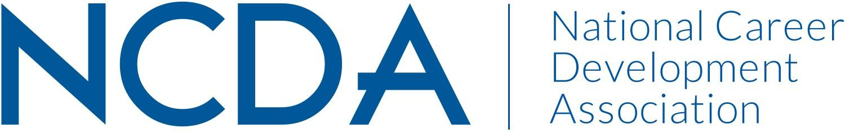

NATIONAL CAREER DEVELOPMENT MONTH COMMITTEE
March 15, 2025

Kymmie Cartledge (Co-Chair): kcartledge@lexington1.net
Logann Todd loganndolan@gmail.com
Meredith Brown mbrown@rcbc.edu
Kimberly Carothers kimberlycarothers8@gmail.com

Committee/Council Activities to Date

- Updated brochure for the new theme
- Social media toolkit for contest advertisement

Projected Plan/Work Completed through September 30.

- Judge submissions (March/April)
- Notify state coordinators, contest participants, and NCDA members of winners (Late April)
- Secure contest theme and update brochure for the upcoming contest before NCDA
Conference in June (before June)
- Develop new ways to celebrate winners both at the NCDA conference and virtually
- Curate resources for career development professionals (K-12 specifically) and create
- connections to the theme of the poetry and art contest and the National Career Development Month (ongoing)
- Develop a possible podcast episode for November 2025
- Plan to celebrate the 60th Poetry and Art Contest
- Create a transition plan for new chairs

Budget Requests: None (outside of Poetry and Art Contest prizes)

