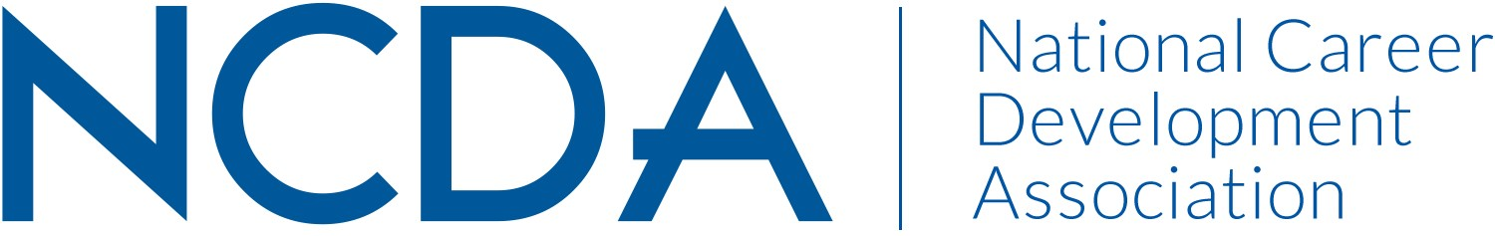

NCDA RESEARCH COMMITTEE REPORT

March 20, 2025

Chair
Deb Osborn
1114 W. Call Street
The Florida State University
Tallahassee, FL 32306-4053
dosborn@fsu.edu

Co-Chair:
Jon Borland
East Tennessee State University
PO Box 70701
Johnson City, TN 37614-1710
borland@etsu.edu

Co-Chair:
Brian Calhoun
Associate Professor of the Practice, Department of Education
Tribble Hall - Room A308B
Wake Forest University
P.O. Box 7406
Winston-Salem, NC 27109
calhoubm@wfu.edu

List Committee Members

Jonathan Adams
Sungsik Ahn
Shadin Atiyeh
Elif Balin
Abby Bjornsen-Ramig
Jon Richard Borland
William Briddick
Nathaniel Brown
Emily Bullock
Stephanie Burrows
Brian Calhoun
Darrin L Carr
Chris S DaSambiagio-Moore
Abiola Dipeolu
Melanie Evangelista
Lia D – Falco
Seth C. W. Hayden
Latoya Haynes-Thoby
Janet Hicks
Youn Jung Ho
Kimberly Howard
Chris Lafever
Jason Li
Qiong Li
Yangyang Liu
Ayla Ludwig
Julia Makela
Spencer Niles
Kelechi Nnaji
Sarah Patterson-Mills
Sabrina Quiroga
Patrick J. Rottinghaus
Donna E Schultheiss
Rana Sedeeq
Patricia Smith
V. Scott Solberg
Jacob Stamm
Tennille Sullivan
Mitali Temurnikar
Margi Williams

Committee/Council Activities to Date
During our final report for 2024, the Research Committee outlined several possible projects that the research committee identified as priorities for NCDA and requested board direction and possible funding. We were subsequently directed to survey the other NCDA committees to determine what NCDA-sponsored research has been conducted in the last five years, and which, if any had been funded. We completed that research at the beginning of the year. Three committees reported NCDA-sponsored research in the past 5 years: leadership academy, technology and international student services. Leadership academy and the international student services committee both reported receiving NCDA funding for research projects. Due to the timing of regularly scheduled NCDA Research Team responsibilities, i.e., selecting the CDQ award and the graduate student research award, we have decided to pause on identifying additional projects until we have completed those tasks.

Recommendations to/requests of the NCDA Board:
- Work with ACES and SVP to collaboratively update the “2013 state of career interventions” white paper.
- Request NCDA committees to indicate on mid and final reports any research-related projects being undertaken by that committee, along with a reminder to please consult with the research committee to assure that no efforts are being duplicated and possible collaborations among committees be encouraged.
- Create a more visible place on the NCDA website for research.
- Create opportunities for making connections between experienced/new researchers, students/faculty, researchers/practitioners.
- Consider creating a "research track" throughout the conference schedule
- Determine if the development of briefs (max 5 pages) on evidence-based practices for varied topics (career indecision, career transitions, etc.) or groups (K-12, veterans, etc.) would be a worthwhile investment and if so, determine the infrastructure/process for this (perhaps involving one or more committees to vet any proposals), and where this information would be housed on the website.

We believe that each of these recommendations as well as our continued activities would contribute to the strategic priorities identified by the NCDA board. Identifying recipients of the research awards contributes to Goal 1 of cultivating community via membership recognition. If NCDA moves forward on the above recommendations, this will result in expanded membership benefits, also a component of Goal 1, and also contribute to Goal 2, professional development. If the NCDA Board invests time and effort into recommendation #6, this will positively impact Goal 3 of Advocacy, as members and the public would have access to brief, comprehensive information about the efficacy of various career interventions and evidence-based practices to support research, grants, and policy efforts.

Projected Plan/Work Planned to be Completed through September 30.
By the end of the fiscal year, we anticipate having completed our tasks of providing recommendations for the two awards. In addition, we will determine priorities and any budgetary requests for the next fiscal year and work on those proposals. We will continue to review research proposals.

