NCDA MID-YEAR REPORT
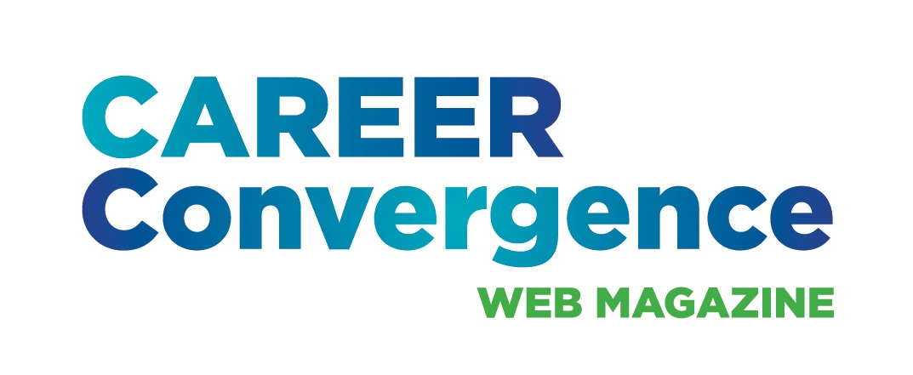

CAREER CONVERGENCE WEB MAGAZINE
March 15, 2024

Editor: Melanie Reinersman, webeditor@ncda.org

Associate Editors: Natasha Barnes, David Dietrich, Candina Janicki, Vonya Hodrick, Meredith Montgomery, Elyse Pipitone, Billie Streufert,
Field Editors: Mason Murphy, Willa Smith, Regina Gavin Williams

Activities to Date

- Published new issues on the first of each month (except Jan 1 and July 1), bringing the total issues up to 218 (since 2003)
- Published 7 new articles, plus one Tech Tip, each month. Electronic distribution to over 28,000 emails on the first of the month and over 1600 articles archived
- Achieved record-high hit rates for an article on artificial intelligence (AI) as well as on the series on teaching theory, from the Counselor Ed Academy participants
- Held a conference call on Dec 6, 2023
- Monitored comments posted on articles
- Tweeted each month, with links to the issue and each article
- Selected (by editors’ votes) the annual “Career Convergence Recognition Award” winner
- Fulfilled 5 requests for CEs
- Completed the 20th anniversary celebration of the web magazine, including a podcast on using Career Convergence
- Selected 2 new co-associate editors (Paul Bredderman and Jane Frisch) and 1 new field editor (Regina Williams); Said good-bye to Linda Evans, Kyle Inselman and Amy Pierce-Danders.

Projected Plan/Work Completed through September 30.

- Continue to publish monthly web magazine
- Plan more articles on trending topics, such as AI, mental health, etc
- On-board 2 new co-associate editors and search for one more (for the Features dept)
- Begin to publish a new series in cooperation with the NCDA Global Career Connections Committee
- Discuss marketing with NCDA’s social media coordinator
- Implement a new AI policy regarding submissions
- Follow-up on the content analysis and determine ways to share/use the results
- Hold a committee meeting at the NCDA San Diego conference in June

